Sam Lee

2/8/18

CPE 64

Professor Kiran

Lab Report #0

Part 1:

A breadboard is a solderless device for with electronics and test circuit designs. Most electronic components in electronic circuits can be interconnected by inserting their leads or terminals into the holes and then making connections through wires where appropriate. The breadboard has strips of metal underneath the board and connect the holes on the top of the board.

Part 2:

We chose three resistors for this part of the lab. Resistor 1 had a color code of brown, blue, red, and gold. Resistor 2 had a color code of red, black, and brown. Resistor 3 had a color code of red, yellow, and brown. Gold was the last color strip for all three resistors that we measured and calculated. With the generic formula given in the lab manual Resistor 1 had 1600 ohms, Resistor 2 had 200 ohms, and Resistor 3 had 240 ohms. These calculations were hand based. When we used the digital multi meter, the reading for Resistor 1 was 1601/1602 ohms, Resistor 2 was 197.3/197.4 ohms, and Resistor 3 had 240 ohms, an exact measurement as the hand calculation.

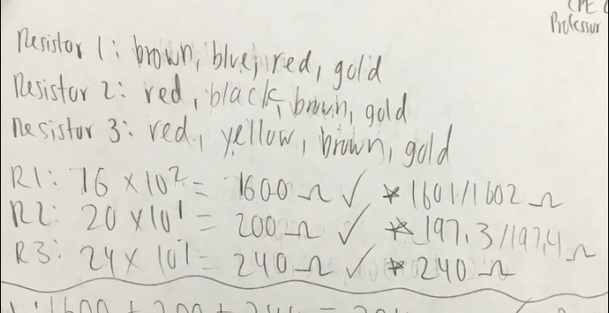

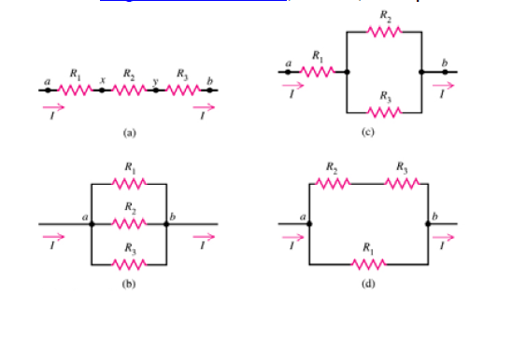

After the calculations of how many ohms each resistor has, we connected resistors in series and parallel as shown in the above diagram. For my calculations, Diagram (A) was 1, (B) was 2, (C) was 3, and (D) was 4. To calculate total resistance of circuit series, I add up all the individual resistances together to get the total amount of resistance in that series. Diagram (A) was a series. I added the resistance of Resistor 1, 2, and 3 together and the total amount of resistance for that diagram based on our resistors was 2040 ohms. The reading of the multi meter calculated 2.04 kilo ohms, which was basically 2040 ohms if we converted it back to ohms. Diagram (B) was a parallel circuit. In order to find the total resistance of a parallel circuit I use the formula “1/Rt = 1/R1 + 1/R2 + 1/R3 + …..”. By doing the calculation for Diagram (B), I got 102.1 ohms for the total resistance of that circuit. The multi meter reading was 101.6 ohms. Comparing these results, my calculations were close to the actual calculation. Diagram (C) was a series and parallel circuit. For these type of circuit I had to calculate the parallel circuits first then add the Resistor 1 since the parallel circuit became a series. The calculation for the total resistance was 408.7 ohms and the reading of the multi meter was 406 ohms. I was only by a little from the actual resistance of that circuit. Diagram (D) was a series and parallel circuit. I first added the series then calculated the parallel circuit to get the total resistance of the diagram. My calculation for the total resistance was 345.1 ohms and the multi meter read 343 ohms, I was off by 2 ohms.

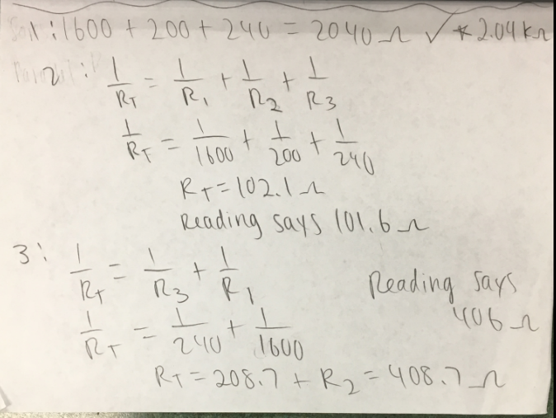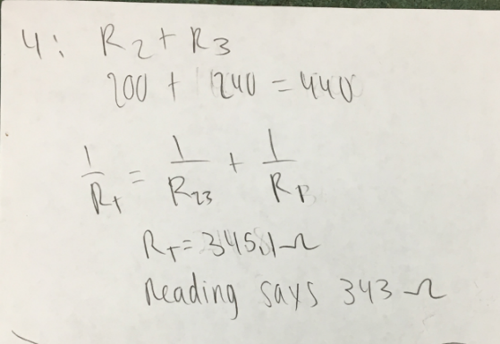

Part 3:

I saw that that electrons flow from the negative battery terminal through the resistor through the LED ending with the positive terminal. He showed us a breadboard and it has columns that are named by letter a-j. He plugged an LED across the center of the board at the locations 10 E and 10 F. He putted the negative lead of the LED at the 10 E hole and the positive one at the 10 F hole. He completed the circuit by plugging the negative battery lead into 10 A ad the red positive lead in 10 J. He was poking the holes on the breadboard from A-D and G-J to light up the LED. He also moved the LED to different row and reconnected it by connecting the leads to that row. He energized the power lines by plugging the negative black battery lead in beside the blueline and the positive red batter lead in beside the red line. With the power lines he was able to connect four LED and they all lighted up and are connected in parallel. He showed how to connect the circuits in parallel and in series too.

I learned how to use solderless breadboard to construct and test circuits and many concepts of using the breadboard. You always must use any resistors between 470 ohms to a 1000 thousand. This is very important because it reduces current preventing overheating in the case of a short circuit and it protects LEDs. A 470-ohm resistor has a color band of yellow, violet, and brown. You must use a resistor when connecting an LED to most batteries. LED can’t tolerate high current. The negative lead of the LED has a flat spot on the edge of the plastic globe. These boards facilitate circuit building by having the negative black lead being connected to the LED by a metal conductor under the holes of 10 A and 10 E and similarly the LED is connected to a positive lead on the holes 10 F to 10 J. If you connect to a different row, then no light will show because each row is separated by an insulating plastic barrier. If you put the LED in a different row, to light it up again just reconnect the lead to the row where you placed the LED at. If the LED doesn’t light up, then the LED might be backwards. The long rows of holes besides the red and blue lines on the board are power lines. To energize those lines, you will have to have the battery lead in beside the color line, red goes to the red line and blue goes to the blue line.

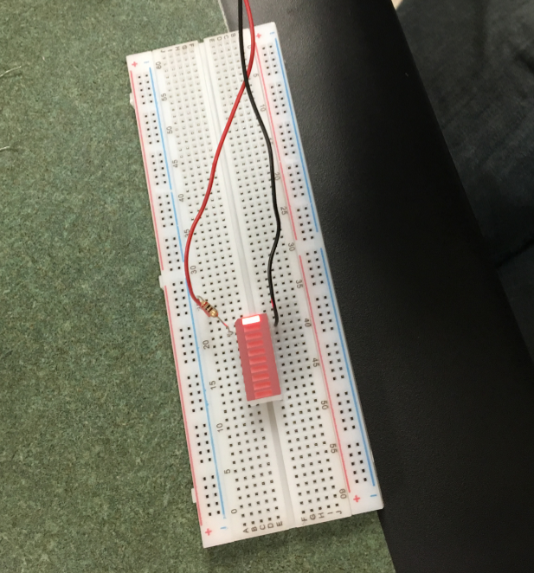

Part 4:

In the first video, he did a demonstration of how to start using an analog discovery kit. It showed the different parts of the kit and the software that it was using which was WaveForms.

I learned that the kit has an analog discovery tool, a USB cable, a detachable fly wire cable, and a packet of male to male connectors as well as audio jack and USB port. The software has two different tools: analog and digital. The analog tool consists of scope, Wavegen, and voltage button, while digital tool consists of analyzer, patterns, and static i/o. The voltage button allows us to control the two power supply using simple on/off buttons. The scope instrument is used to measure voltage differences and be able to gather statistical data. The WaveGen button is used to output a user defined signal.

In the second video, he demonstrated how to use the voltage instrument. He showed us that the V+ is connected to a red wire, V- is connected to a white wire, and the four ground terminals are connected to black wires. He went in depth to define what a light emitting diode, also known as LED.

I learned that the voltage instrument can be used to apply fixed voltages to your circuits either positive or negative. The instruments control the terminal that are labeled as V+ and V-. V+ provides +5 volts relative to the ground V- provides -5 volts relative to ground. The LED has two terminals: anode and cathode. Anode is positive and a longer wire and cathode is negative and a shorter wire. We can also limit the amount of a current passing through an LED by adding a resistor to the circuit.

In the third video, he introduced the voltmeter instrument and how to use it. He showed us what the orange and blue wires. He then went on the software to show us the voltmeter instrument and went through each type of voltages displayed on the voltmeter. He went over the signs of the voltages. After that, he then showed us how to measure the voltage difference between the terminal of a 9 volt battery and connected the leads to the terminal. Then, he measured the voltage in a circuit schematic.

I learned that the 1+ terminal is connected to an orange wire and the 1- is connected to an orange wire with white stripes on it. The 2+ terminal is connected to a blue wire and the 2- is connected to the blue wire with white stripes on it. The voltmeter displays the voltage between the 2 channel 1 terminals or 2 channel 2 terminals. The different types of voltages are displayed by the voltmeter are DC. true RMS, and AC RMS. The DC measurement is the most appropriate for constant voltages while the other options are more applicable to time varying voltages. When we measure a voltage, the terminals labeled with a negative sign, 1- and 2-, connect to the terminal, which is assumed to be at the lower voltage. The terminal that are labeled with a positive sign, 1+ and +, connect to the terminal which is assumed to be at the higher voltage. Reversing the leads changes the sign on the displayed voltage.

Part 5:

In first video, I learned what NI Multisim is and how to use it. Multisim is a highly graphical environment which abstracts away the complexities of traditional circuit simulation. It provides the perfect environment to assist students in learning circuit theory, improve understanding of circuit behavior through measurement, and engage in hands on interactive circuits. It can help define circuits earlier in the design flow, identify common design mistakes, and reduce costly prototype iterations caused by an ineffective design topology.

In the second video, I learned the six basic types of logic gates and how to create the gates as well as testing them. I put a NAND, NOR, NOT, AND, OR, and XNOR gate in the diagram, all line up with each other from top to bottom on the right side of the diagram. After that I put a VC supply on the left side and a ground on the bottom left side. I placed two SPDT switches between the gates and the VC supply. I connected the SDPT switches to the VC supply and ground. After that I connected the NAND gate to the VC supply and the other gates to the lines that connected the switches with the SPDT switches. I colored each line different and had one line red and the other green. After that, I placed six probes and connected them to each gate. Each probe has 2.5V. After all of that, I started the simulation. If I flipped the switch then three probes will turn blue while the others stay white, indicating that hose probes are powered on or off. In the third video, I learned again about each logic gates and inputs and outputs for each gate.

